**OS Module** (Operating System)

**1. Concept – OS Module kya hai?**

Socho tumhare computer ka **engine (Operating System)** hai. Tum Node.js se directly usse baat kar sakte ho.

👉 Tum jaan sakte ho:

* Tumhara OS kaun sa hai (Windows, Linux, Mac)
* Kitna free memory bacha hai
* Kitna total memory hai
* Tumhare CPU ki details
* Hostname, username, home directory

Aur ye sab jugad hoga 👉 **os module** se.  
Ye bhi ek **built-in module** hai (npm install ki zarurat nahi).

**2. Syntax & Code – OS Module ka use kaise kare?**

**Step 1: Import**

const os = require('os');

**Common Functions (Desi Style):**

👉 **OS ka naam (type)**

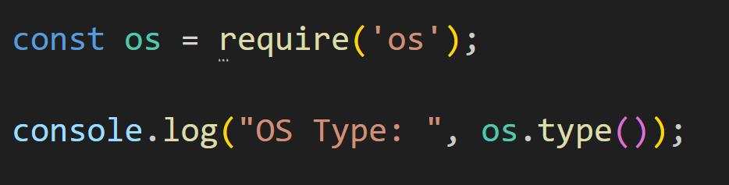Output:



👉 **OS platform**

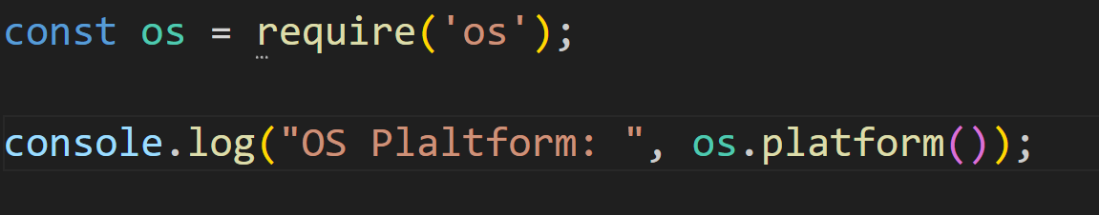

Output:



👉 **CPU Architecture**

console.log("Architecture:", os.arch());

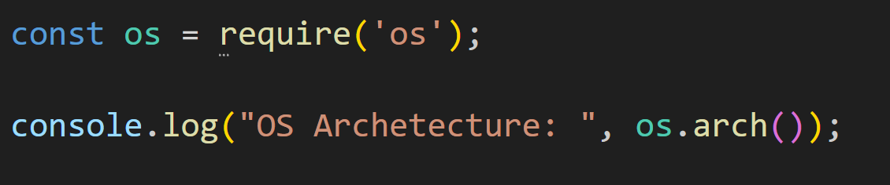

// x64 / arm



👉 **Total Memory (bytes me)**

console.log("Total Memory:", os.totalmem());

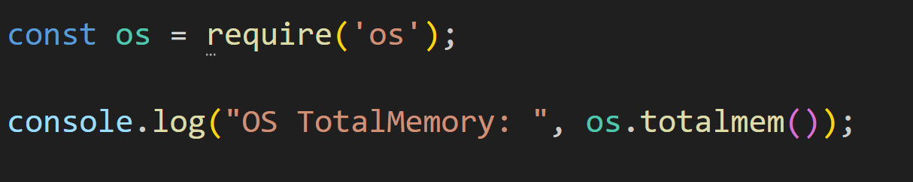

Output:



👉 **Free Memory (bytes me)**

console.log("Free Memory:", os.freemem());

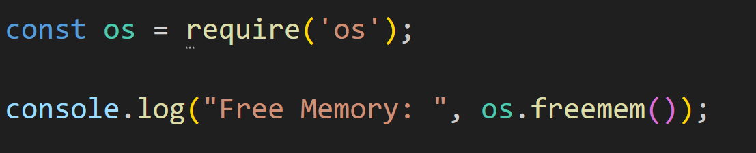

Output:



👉 **Home Directory**

console.log("Home Dir:", os.homedir());

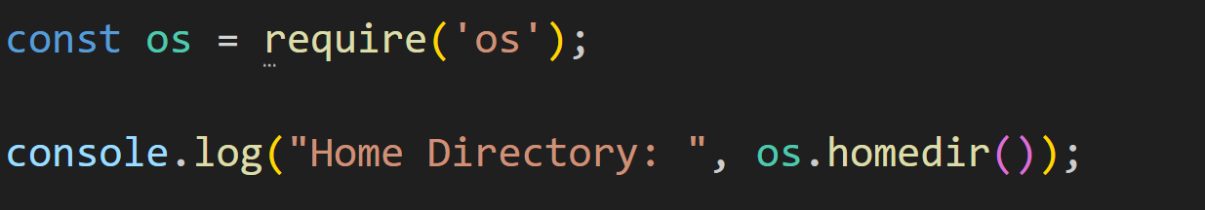

Output:



👉 **Hostname**

console.log("Hostname:", os.hostname());

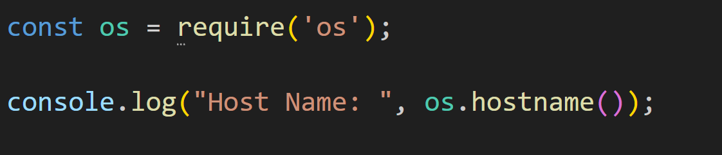

Output:



👉 **System Uptime (seconds me)**

console.log("Uptime (seconds):", os.uptime());

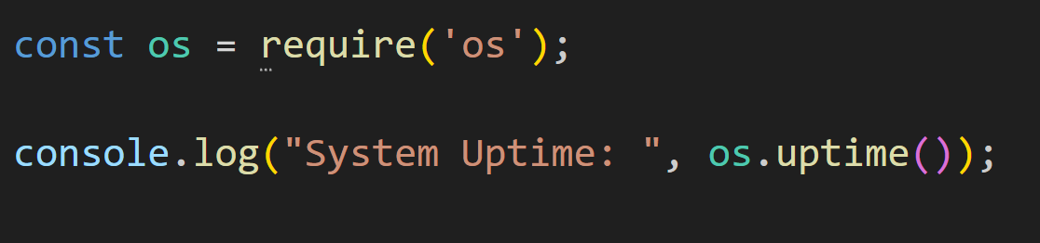

Output:



👉 **CPU Info**

console.log("CPU Info:", os.cpus());

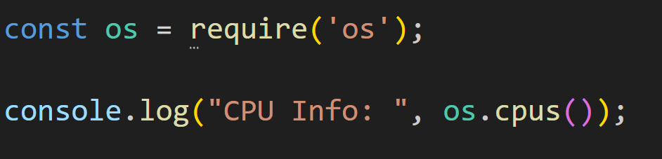

Output:

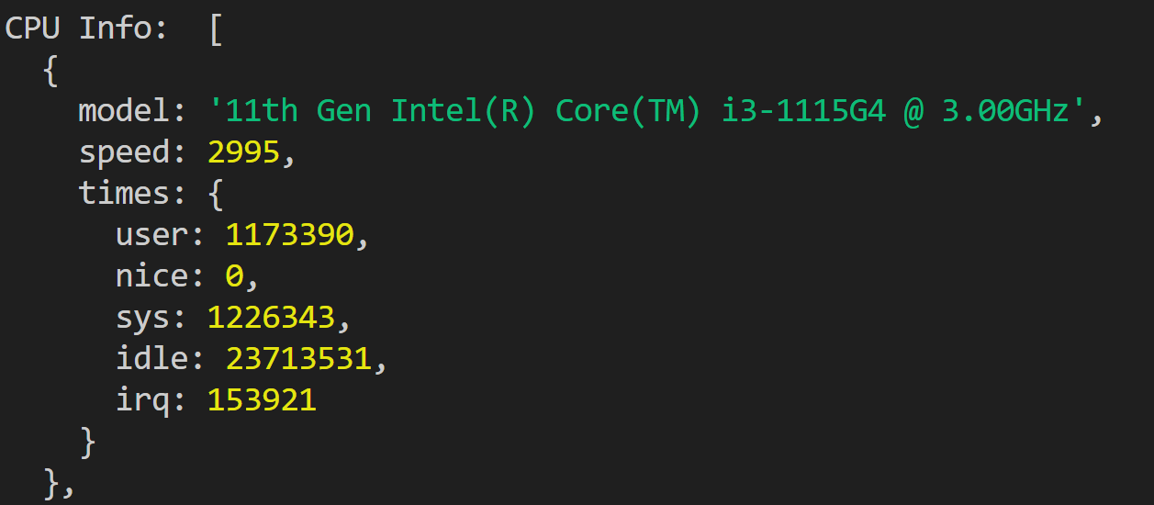

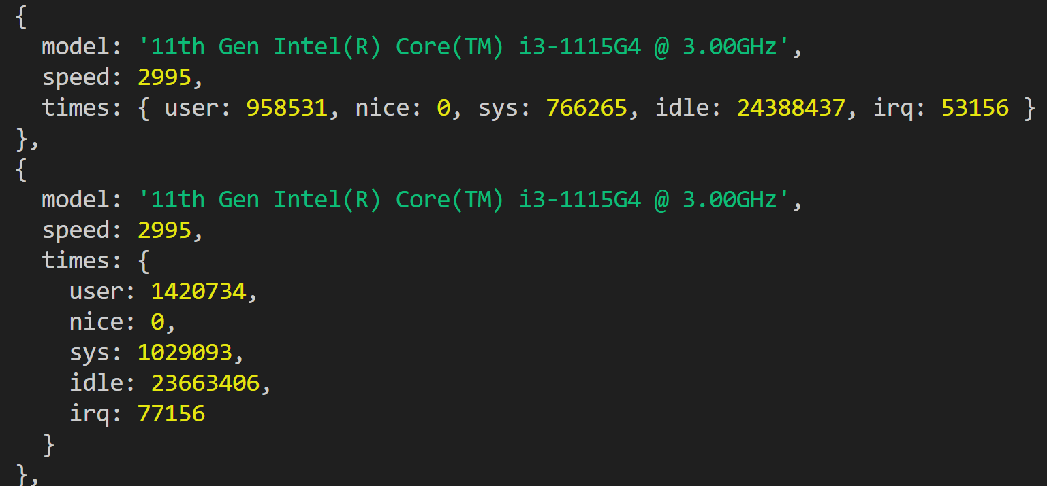

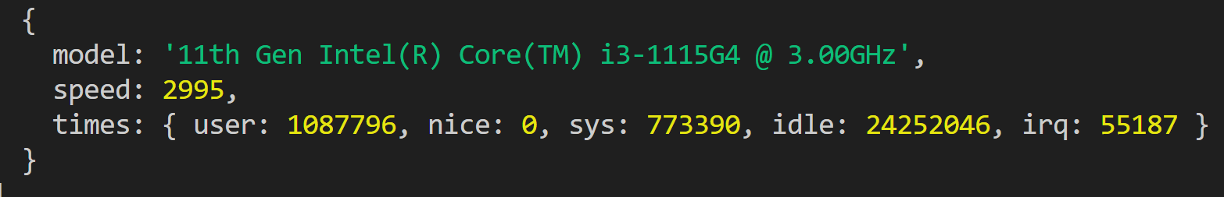

👉 **Network Interfaces**

console.log("Network Interfaces:", os.networkInterfaces());

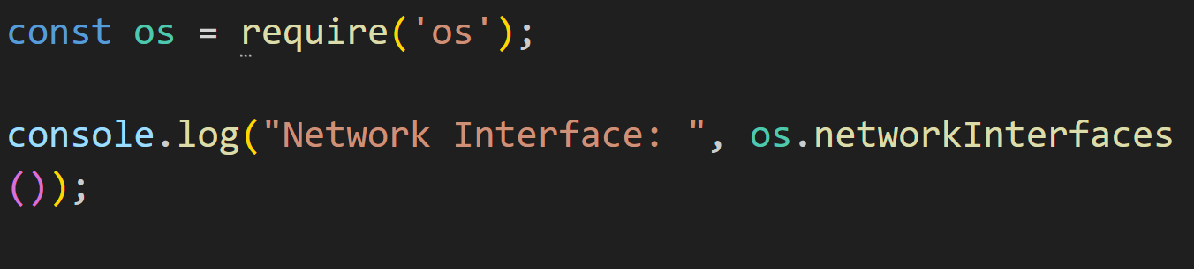

Output :

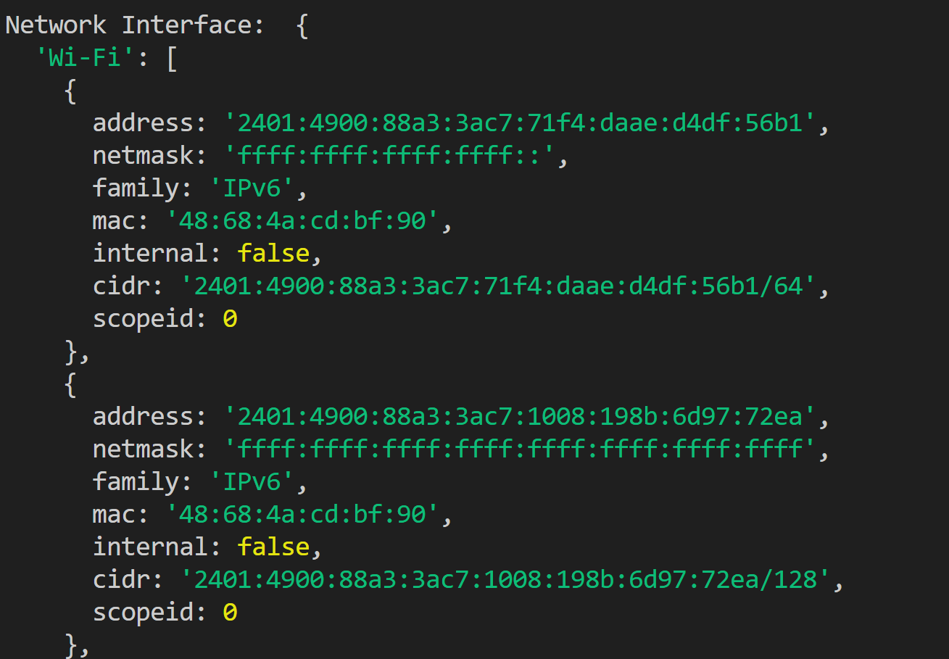

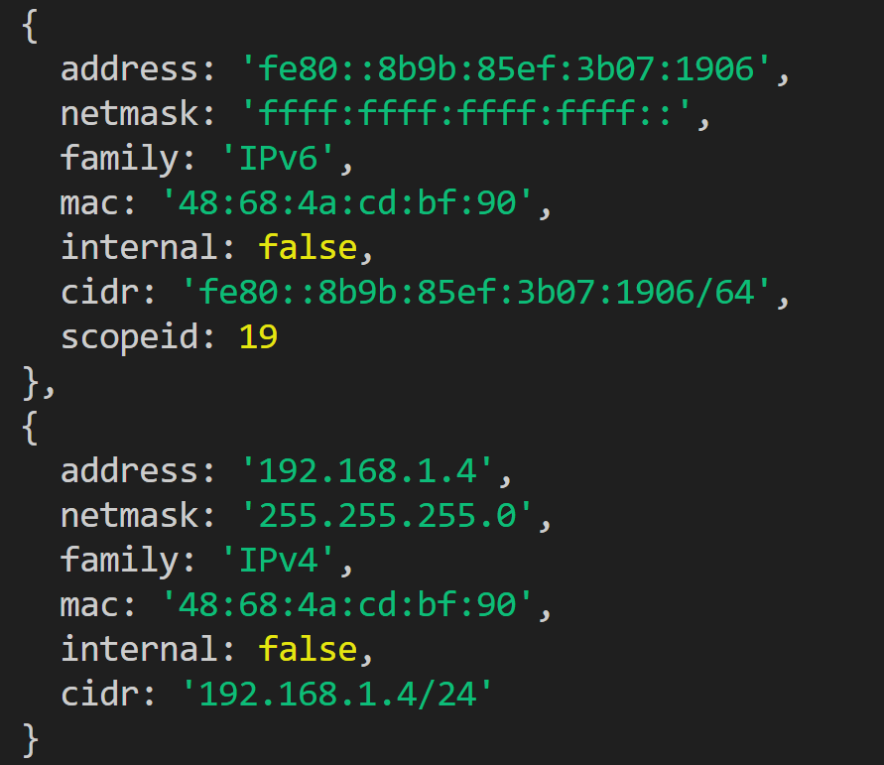

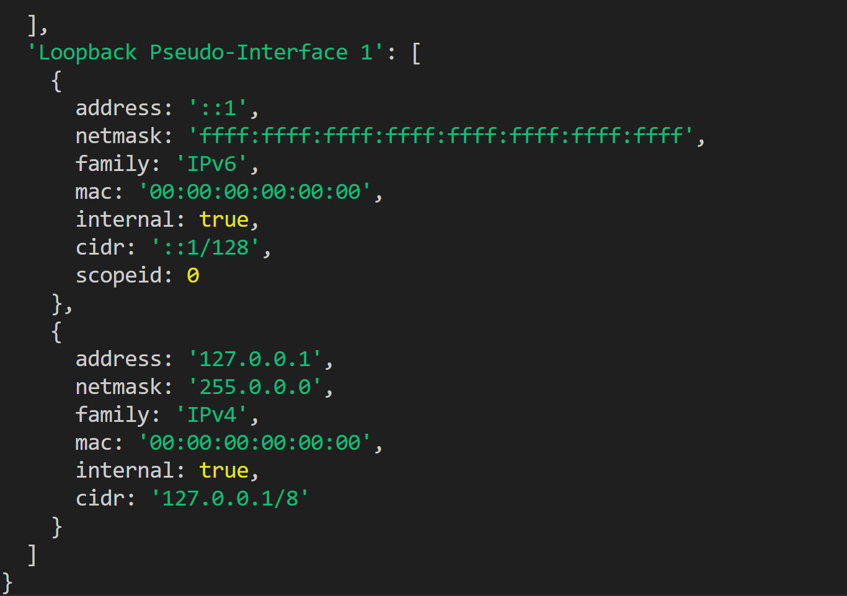

**3. Exercise – Practice Time**

**📝 Exercise 1: System Info Reporter**

Ek program likho jo user ke system ki sari details print kare:

* OS Type
* Platform
* Architecture
* Total & Free Memory (MB me convert karke)
* Hostname
* Uptime (minutes me)

**systemInfo.js**

const os = require('os');

console.log("OS Type:", os.type());

console.log("Platform:", os.platform());

console.log("Architecture:", os.arch());

console.log("Total Memory:", (os.totalmem() / 1024 / 1024).toFixed(2), "MB");

console.log("Free Memory:", (os.freemem() / 1024 / 1024).toFixed(2), "MB");

console.log("Hostname:", os.hostname());

console.log("Uptime:", (os.uptime() / 60).toFixed(2), "minutes");

**📝 Exercise 2: CPU Checker**

Ek program likho jo system ke har CPU core ka model aur speed print kare.

**cpuInfo.js**

const os = require('os');

const cpus = os.cpus();

cpus.forEach((cpu, index) => {

console.log(`CPU ${index + 1}:`);

console.log(" Model:", cpu.model);

console.log(" Speed:", cpu.speed, "MHz");

});

**🎯 Desi Summary**

1. **Concept** → OS module tumhare computer ke “engine room” ka CCTV hai 🚀
2. **Syntax** → const os = require('os')
3. **Functions** → type(), platform(), arch(), totalmem(), freemem(), cpus()
4. **Exercises** → System Info Reporter + CPU Checker